Exercises (Python)Python Programming
Exercises (Python)Exercises

6.3 An object starts moving at from position s0 with velocity v0 and gains a constant acceleration of a. After time t, compute its position and velocity.

Write a class to define the particle and provide the following methods:
def accelerate(self, a, t):
# dv/dt = a
# ds/dt = v
# v = ∫a.dt = at + s0
# s = ∫v.dt = ∫at.dt = at^2/2 + s0.t + v0

def getPosition(self):

def getVelocity(self):

Perform all calculations in 3D space. Use numpy to simplify the calculations

Numpy

1. Create 4x6 array of floats between 3.5 and 5.5. Display the results to 3 decimal places.

2. Create a 4x6 array of random ints between 10 and 100.

3. Create a 4x6 array of random ints between 10 and 100. Set all the even numbers to 100.

4. Create a 4x6 array of random ints between 10 and 100. Create a new 1D array with all the numbers in the first array that are less than 50.

5. Create a 4x6 array of random integers between 10 and 100. Create a new 4x3 array of the lowest 50% of the original array whilst preserving order.

6. Create a 4x6 array of random integers between 10 and 100. Set the lowest 50% of the array to 0.

7. Create a 6x4 array of ints between 10 and 14 where the first row is filled with 10, the second with 11 and so on.

8. Create a 8x5 array of ints using the "tile" method that looks like:

[[10 11 12 13 10]
[11 12 13 10 11]
[12 13 ...
... 11 12]
[13 10 11 12 13]]

9. Create a 4x6 array of ints. Swap columns 2 and 4.

10. Create a 3x10 array. Rotate the array by 90 degrees, 4 times, so you get back to the original array.

11. Find the intersection of two 1D arrays.

12. Create two 1D int arrays of equal size. Create a new array of the same size, selecting elements from the first array when the element in this array is even, and selecting elements from the second array when the element in the first array is odd.

13. Create a 4x6 array of random ints between 10 and 100. Look up what it means to define a masked array and then create a masked array where all values in the original array that are less than 50 are masked out.

14. Create a 4x6 array of random ints between 10 and 100. Filter this array and produce a 1D array of the numbers divisible by 3.

15. Create a 4x6 array of random ints between 10 and 100. Then create a 4x6 array of indices of representing rankings of the first array. For example a 2x3 array
[[49 56 61]
[63 39 97]]
yields the rankings
[[4 0 1]
[2 3 5]]

16. Create a 1D array of random ints of size (30,) containing only the numbers 10, 11, 12, 13 or 14. Now create 30 'one hot encodings' for the original array. For example a set of 'one hot encodings' for:
[20, 22, 21, 22, 20, 22]
would be:
[1 0 0]
[0 0 1]
[0 1 0]
[0 0 1]
[1 0 0]
[0 0 1]

17. Create two vectors representing points in 3D space. Calculate the distance between the points.

18. Perform a Cartesian to Spherical coordinate transformation on each of the Cartesian unit vectors:
iHat = [1, 0, 0]
jHat = [0, 1, 0]
kHat = [0, 0, 1]

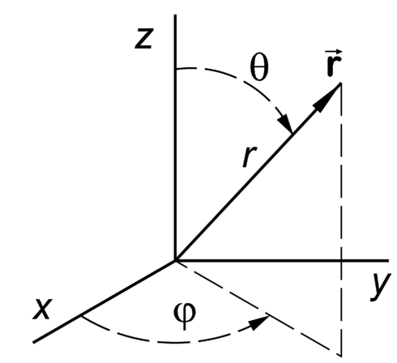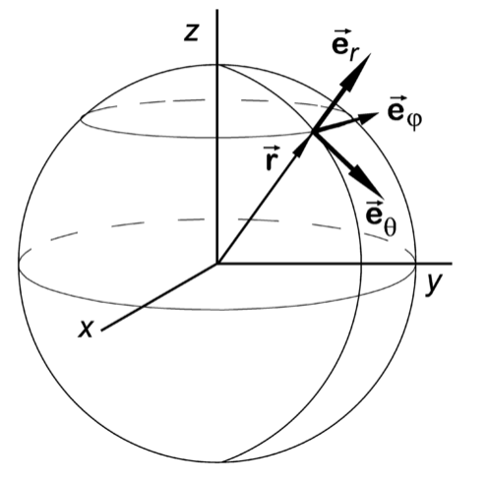
Note that the transfomation for kHat causes a singularity in Spherical coordinates, so try vectors very near kHat instead:
kHat_plus = [+0.0001,0,1])
kHat_minus = [-0.0001,0,1])

__________________________________________________________

Pandas

In all these questions use the same source file:
../MiniProject/wtk_site_metadata.csv

1. Print the column names of the csv file.

2. Create a new dataframe with just the 'longitude' and 'latitude' columns.

3. Create a new series from the 'State' column of the dataframe and then remove duplicates.

4. Print out the row with the largest 'longitude'.

5. Create a new dataframe containing rows with state equal to 'Rhode Island'. Retain the 'longitude' and 'latitude' columns. Reset the index such that it starts at 1.

6. Create the same dataframe 'Rhode Island' as in the previous exercise. Print the dataframe without the index, display every row to a precision of 2 decimal places

7. Create the same dataframe 'Rhode Island' as in the previous exercise. Now add an extra column called 'power' that is computed as the product of the columns 'capacity_factor' and 'wind_speed'.

8. Work with the dataframe 'Rhode Island' as in the previous exercise with the extra column called 'power'. Reorder the columns such that the first three columns are 'capacity_factor', 'wind_speed' and 'power' and print the first 5 rows of the dataframe.

9. Work with the dataframe 'Rhode Island' as in the previous exercise with the extra column called 'power' and the column headings resorted. Now sort the dataframe in descending order of 'power'.

10. Work with the dataframe 'Rhode Island' as in the previous exercise with the extra column called 'power' and the column headings resorted. Create a new sorted dataframe with rows from the 'Rhode Island' dataframe with a 'power' greater than 3.

__________________________________________________________

Intermediate Questions

1. removeDuplicatesFromLists
How do you find the intersection of 2 lists (i.e. those elements common to both lists)? For example:
list1 = [ 1, 3, 5, 7, 5, 4, 3, 2, 1 ]
list2 = [ 2, 4, 6, 8, 6, 4, 3, 2, 1 ]

have these elements in common:
[1, 2, 3, 4]

2. palindromes
Write a function that takes a list as a parameter and checks if it is a palindrome. Use the following test data:
listA = [ 5, 7, 3, 22, 15, 6, 15, 22, 3, 7, 5 ] # is palindrome
listB = [ 5, 7, 3, 22, 15, 6, 6, 15, 22, 3, 7, 5 ] # is palindrome
listC = [ 5, 7, 3, 22, 15, 6, 7, 15, 22, 3, 7, 5 ] # is NOT palindrome
listD = [ 5, 7, 3, 'A', 15, 'Z', 15, 'G', 3, 7, 5 ] # is NOT palindrome
listE = [ 5, 'A', 3, 'G', 15, 6, 15, 'G', 3, 'A', 5 ] # is palindrome

3. flatten
Write a function that flattens multi-dimensional lists. For example:
listA = [[1, 2, 3], [4, 5, 6], 7]
listB = [1, [2, 3], [4, 5, [6, [7]]]]

get flattened to:
[1, 2, 3, 4, 5, 6, 7]
[1, 2, 3, 4, 5, 6, 7]

4. compress
Write a function that removes adjacent duplicates in a list, such that for example:
compress([4,7,5,5,5,3,4,4,4,2,2])

gives the output:
[4, 7, 5, 3, 4, 2]

5. hashTables
Study the data in the file:
data/customer.txt

Read the data from the file and set up a dictionary such that the key is formed from the FIRSTNAME, INIT, LASTNAME fields and the values from the remaining fields. Note that some keys do not have an initial.

Once the hash is complete perform a search for two different entries:
key = ('WILLIAM', 'T', 'JONES')
print key, customer[key]

key = ('DAVID', '', 'BROWN')
print key, customer[key]
__________________________________________________________

Advanced Questions

A1. Roman Numerals
Create two subroutines that convert a decimal number in the range 1 to 4000 to Roman numerals, and back. You will need to use lookup tables to simplify the code (see 1.py in the resources folder).
Warning: This question is rather more difficult than it looks.

The Roman numerals are:
I 1
V 5
X 10
L 50
C 100
D 500
M 1000
Roman numerals generally go from large values to small values, with one notable exception: a single small numeral can be used before a larger numeral, and is then subtracted from that larger numeral. So XC means 90. However, only the following combinations are valid:
IV 4
IX 9
XL 40
XC 90
CD 400
CM 900

A2. Stems
Word prefixes are also called stems. Write a program that reads the file /usr/share/dict/words and finds the most popular stems of size 2 to 29 (if you get a tie, just pick one).

For example, the stems for the following input:
test
tester
jest
compute
computer
literate
literal
literacy
continue
collaborate

would be:
Most popular stem of size 2: co (occurs 4 times)
Most popular stem of size 3: lit (occurs 3 times)
Most popular stem of size 4: lite (occurs 3 times)
Most popular stem of size 5: liter (occurs 3 times)
Most popular stem of size 6: litera (occurs 3 times)

A3. Word Frequencies
Read the file /usr/share/dict/words and print a histogram of the occurrence of each size (in percent), giving output similar to the one below:

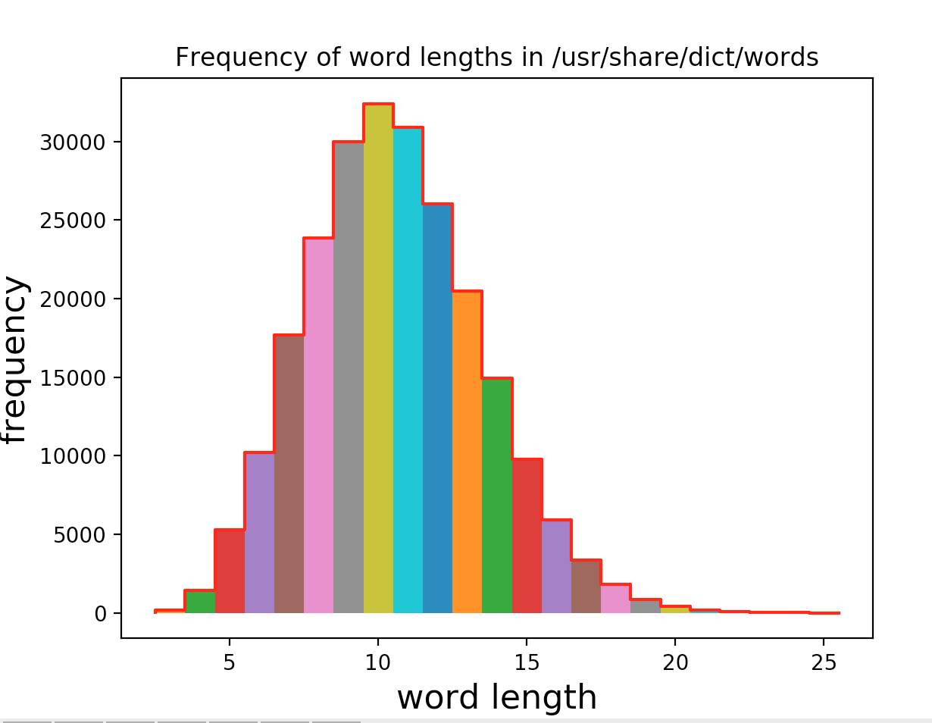

A7. Orbiting Particle
Write a program with a Particle class that plots the position of the particle as it orbits a central point under the influence of an inverse square force (F).

Define a the class along the lines:
class Particle:
def __init__(self, name, x0, v0): ...
def getPosition(self): ...
def next(self, dt): ...

where x0 and v0 are the initial position and velocity of the particle. The next method calculates the new position (x) and velocity (v) of the particle a time interval dt later.

Call the next method repeatedly and use the formulae:
dv = F * dt / m
dx = v * dt
to calculate the new position (x) and velocity (v) of the particle:
v = v + dv
x = x + dx

Plot the resulting orbit in 3D with matplotlib.

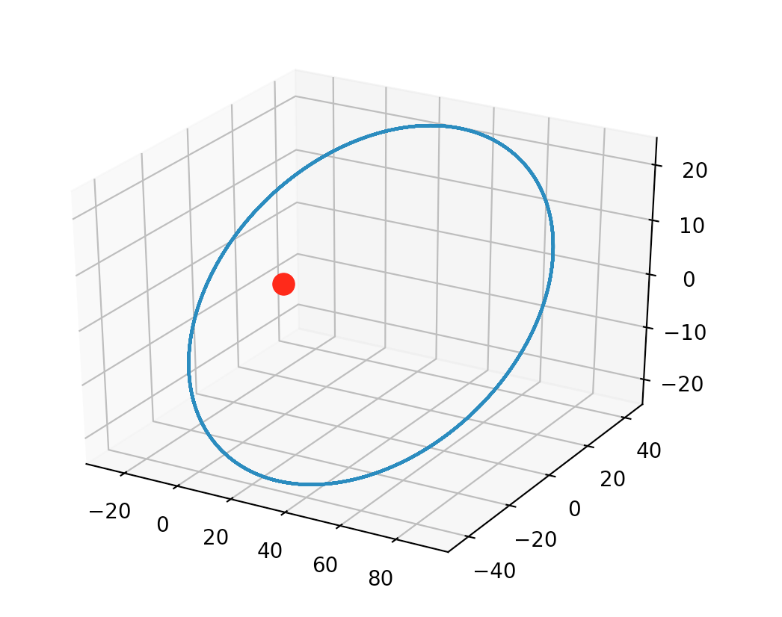

A8. Simulation
Convert the previous example into a simulation using MatPlotLib.

A9. Image Processing
Write a Python program that generates a chessboard JPEG file. Use Numpy to create a 3D array representing the pixels of the chessboard. The array should alternate between black and white pixels and look like:
[[
[ 0 0 0]
[ 0 0 0]
[ 0 0 0]
[ 0 0 0]
[ 0 0 0]
[ 0 0 0]
[ 0 0 0]
[ 0 0 0]
[ 0 0 0]
...
[255 255 255]
[255 255 255]
[255 255 255]
[255 255 255]
[255 255 255]
[255 255 255]
[255 255 255]
[255 255 255]
[255 255 255]]
...
[[ 0 0 0]
[ 0 0 0]
[ 0 0 0]
...
Once you have created the Numpy array, you can use:
PIL.Image
to display the image and
PIL.Image.fromarray
to create a saveable image. Consult the online documentation for more details.

A10. Fourier Series
Define a stair function and use MatPlotLib to plot this function.
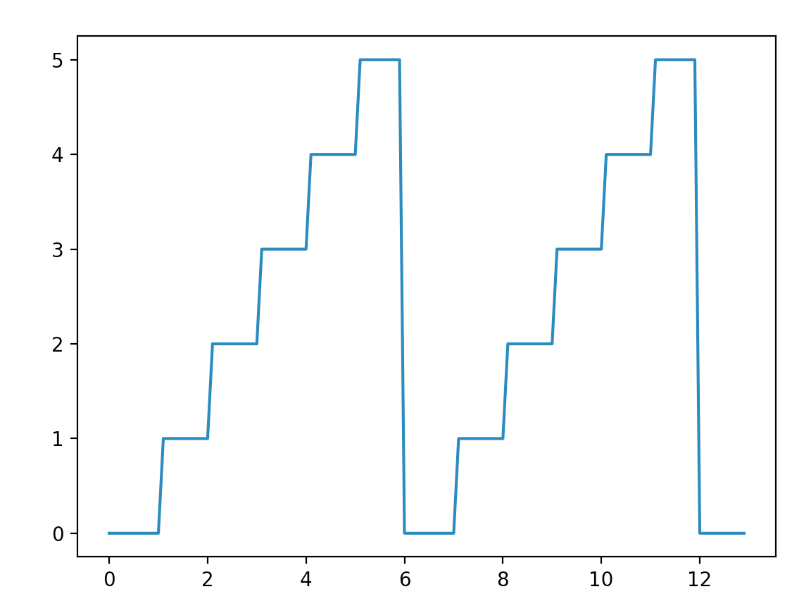
Now calculate the Fourier coefficients corresponding to this function, so that you can calculate the Fourier approximation function. Refer to:
http://www.thefouriertransform.com/series/coefficients.php
as a guide to the formule to be used. Your stair function will be f(t) and the Fourier approximation function will be g(t).

You will need to calculate the Fourier coefficients a[0], a[m] and b[m] where m in theory varies from 1 to infinity. In practice you get a good approximation by calculating coefficients between m=1 and 50. Use:
scipy.integrate.quad
to perform numerical integration required to calculate the coefficients (don't use analytical integration).

You will now be able to plot both the stair function and the Fourrier approximation:
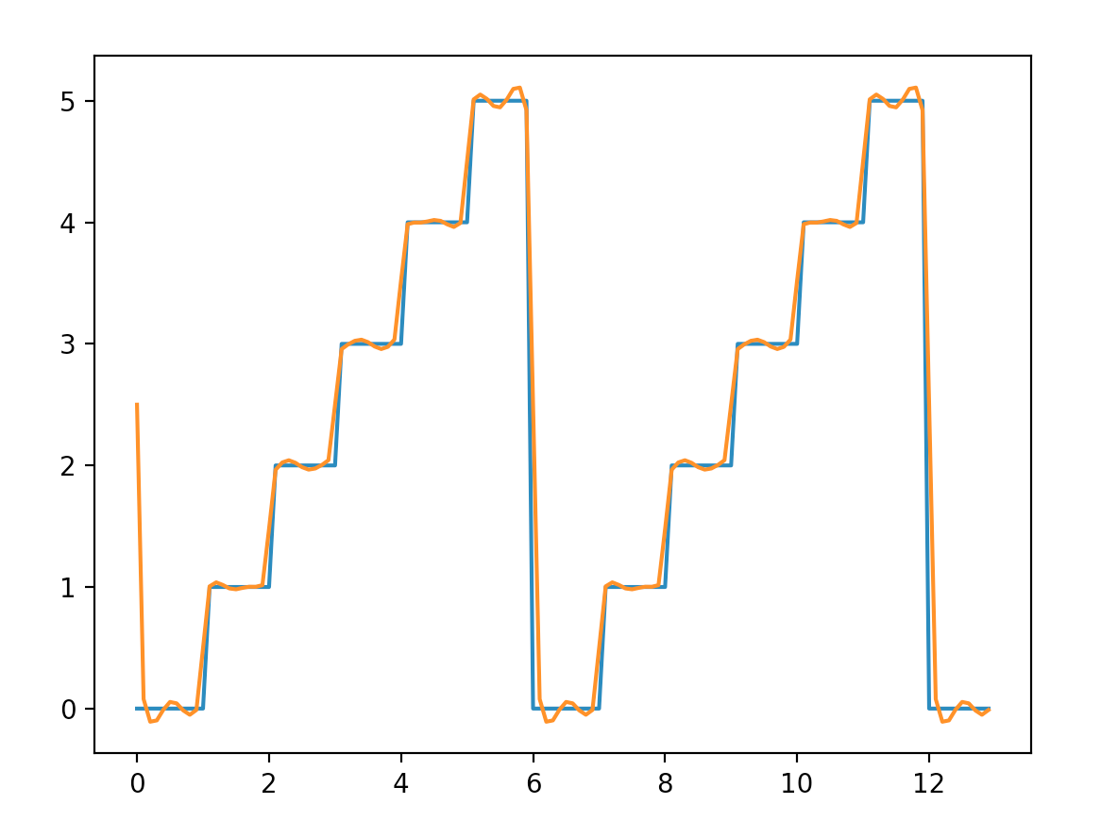

A11. Gaussian Fitting
Use Pandas to open the file:
data/14763.dat

and then print the data and the keys from this file:
gonx i_pin Time
0 -1.7000 1.3456 0.0
1 -1.6980 1.3456 0.0
2 -1.6959 1.3461 0.0
3 -1.6941 1.3460 0.0
4 -1.6920 1.3457 0.0
.. ... ... ...

Now plot this data using MatPlotLib:
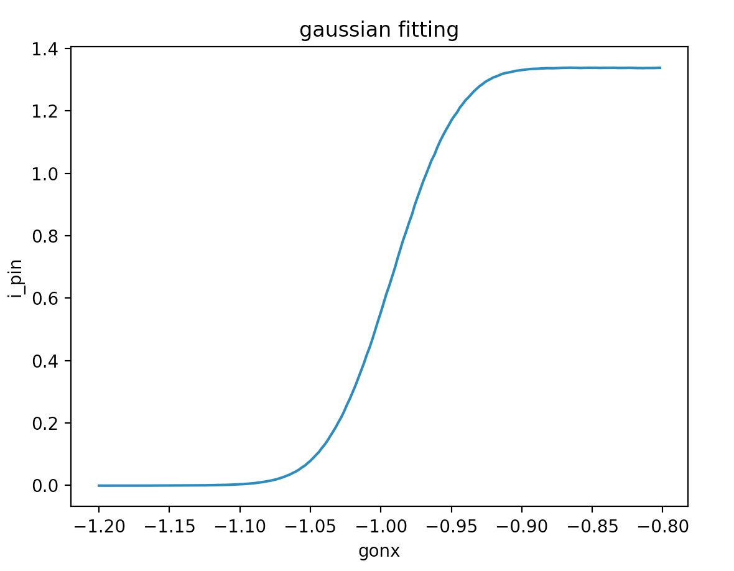
As you can see this is a scan showing change in intensity of the beam. You need to compute and plot differences in gonx to obtain and plot a Gaussian:
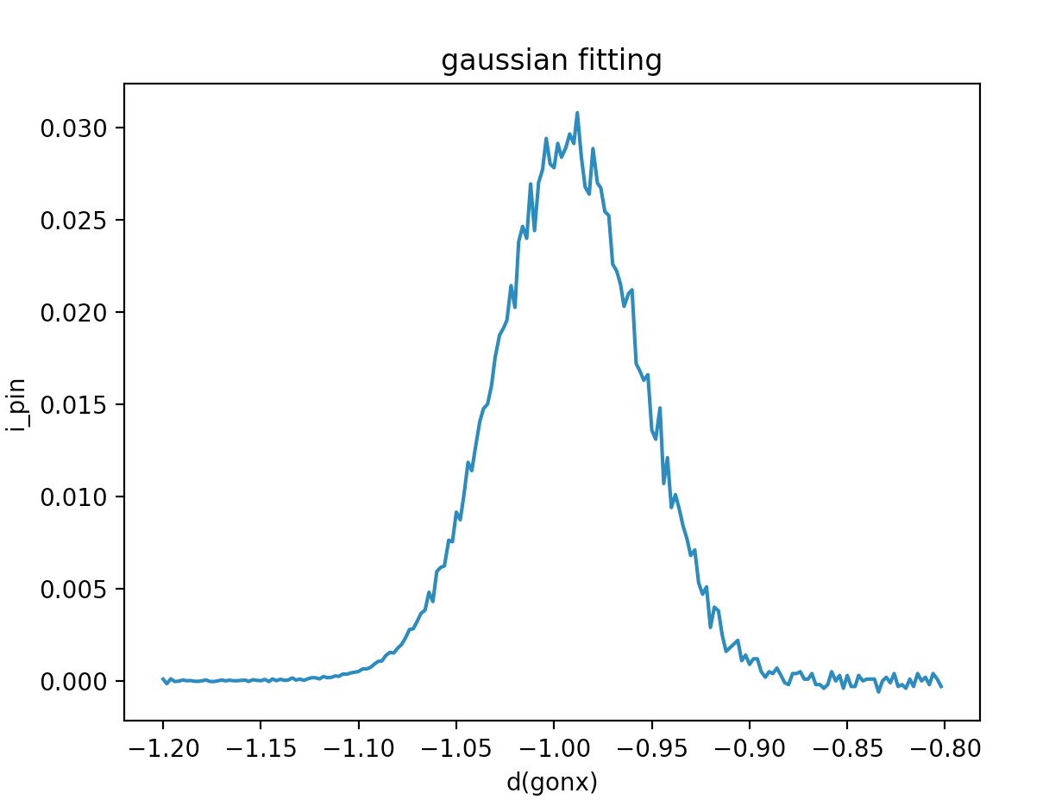
Now use
scipy.optimize.curve_fit

to fit the Gaussian and calculate the peak, μ (center) and σ (standard deviation). Use the function:
def gauss(x, peak, μ, σ):
return peak*np.exp(-(x-μ)**2/(2.*σ**2))

as the function parameter to curve_fit:

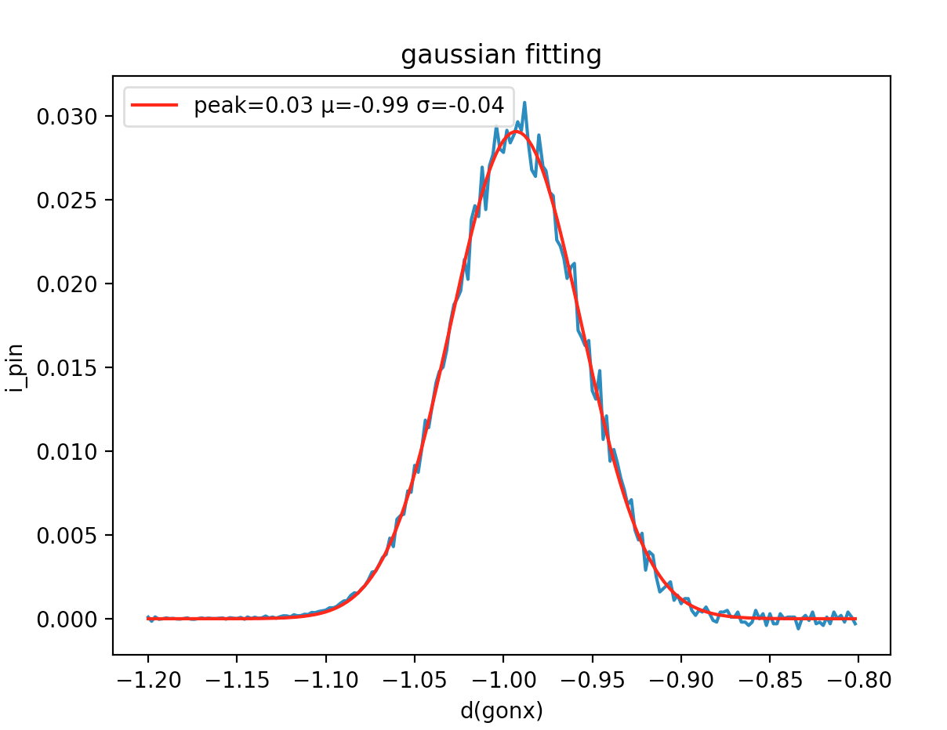

A12. Knights Random Chessboard Walk
Of all the chess pieces, the knight moves in the strangest way; each move is two squares in one direction and one square in an orthogonal direction. Thus if the knight is placed in the center of the board it has 8 possible moves.

Given an empty chess board and a single knight placed on the board, the knight can reach any part of the board by a suitable sequence of moves. If the knight makes a random set of moves, eventually it will visit every square on the board.

Perform a Monte Carlo simulation of a knight performing a random walk across the board. Represent the board by a Numpy array, initially filled with zeros:
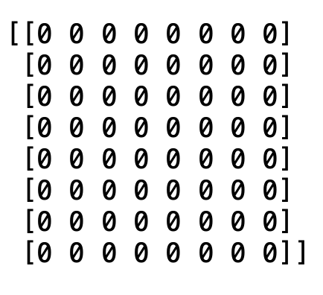
Fill in squares with ones as the knight moves across the board. After a few moves the board will look like:

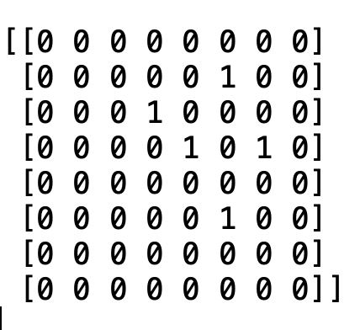
Eventually the board will end up filled:
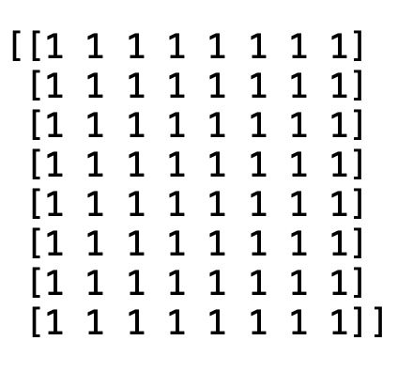
The simulation should reveal that the knight will take a long time to visit each square on a random walk. How many moves will it take to more or less guarantee the knight visits every square of the board.

You might find it helpful to use a generator to calculate each new move.

